**Day 5 Assignment 1**

**Name: Mriganka Patra**

**Email: Mriganka.patra@cognizant.com**

Task 1: Select a moderately complex web application module.

* Include login, product selection, cart management, address entry, payment, and confirmation.

**Test Scenarios**

| **#** | **Scenario Name** | **Description** |
| --- | --- | --- |
| 1 | Login with valid credentials | Ensure registered users can log in successfully |
| 2 | Login with invalid credentials | Check error handling for wrong inputs |
| 3 | Add product to cart | Verify user can select and add item to cart |
| 4 | Edit cart (quantity, remove items) | Ensure cart supports item quantity update and deletion |
| 5 | Apply discount coupon | Validate coupon code logic and discounts applied |
| 6 | Proceed to checkout | Confirm cart details before checkout |
| 7 | Enter delivery address | Ensure valid address can be entered or selected |
| 8 | Select payment method | Test availability of payment modes (Card, UPI, COD) |
| 9 | Payment gateway success flow | Verify successful payment transaction |
| 10 | Payment gateway failure flow | Check system’s response on failed payment |
| 11 | Order confirmation page | Confirm receipt is shown with correct details |
| 12 | Email confirmation | Ensure confirmation email is triggered post-order |

Task 2: Create 10-12 high-level test scenarios covering functional, UI, security, and integration aspects.

**Test Case – Add Product to Cart**

* **Test Case ID:** TC_003
* **Scenario:** Add product to cart
* **Preconditions:**
  + User is logged in
  + Product listing is available
* **Test Steps:**
  + Navigate to product listing
  + Select a product
  + Click "Add to Cart"
* **Expected Result:** Product is added to cart and cart icon is updated
* **Postconditions:** Product remains in cart on page reload
* **Priority:** High
* **Severity if Failed:** Critical

Task 3: Write detailed test cases for each scenario, including:

* Preconditions, test steps, expected results, postconditions
* Priority and severity classification

1. Open Jira
2. 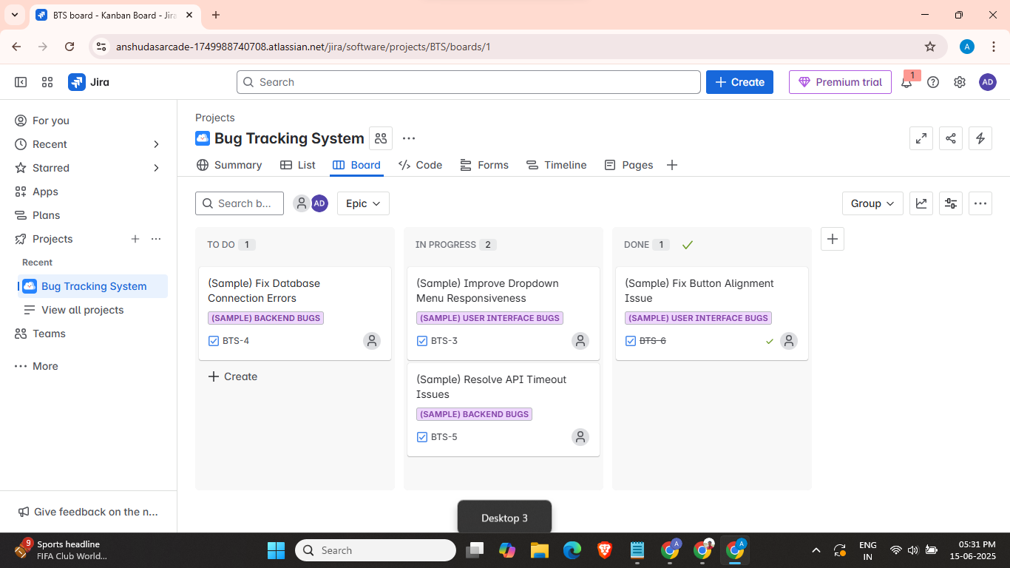
3. Create Epic
4. 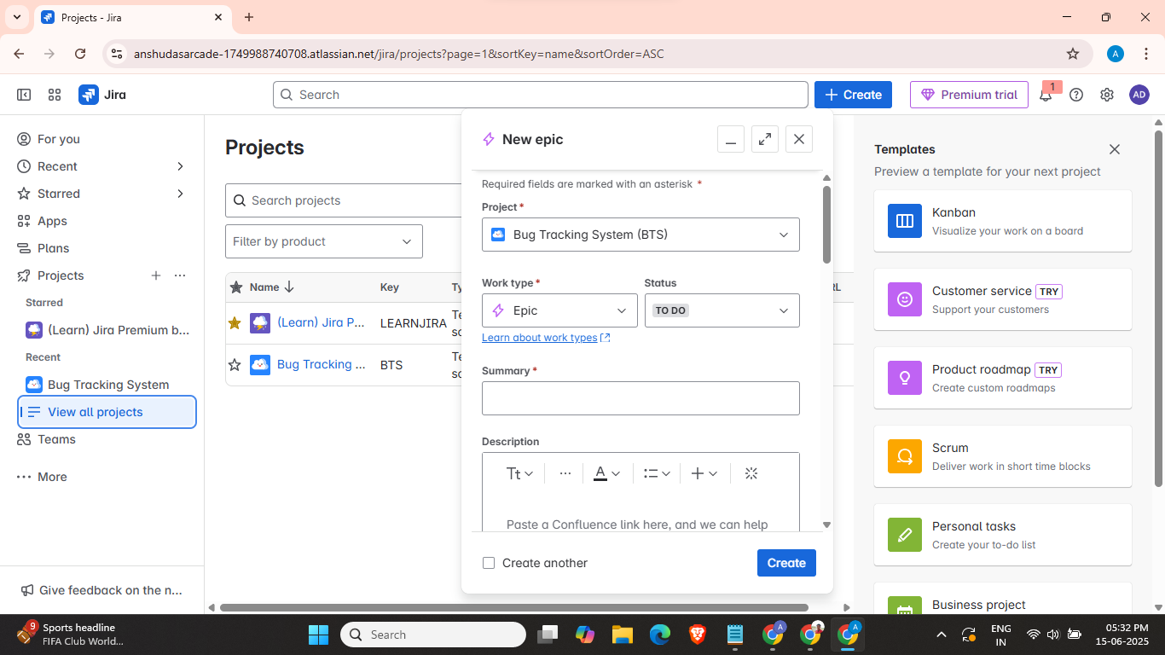
5. 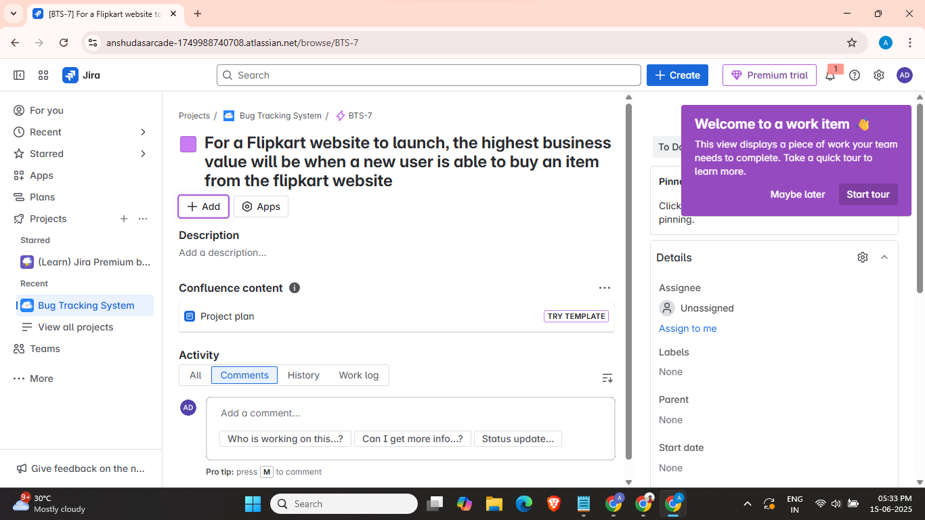

Task 4: Execute all test cases:

* Record results: Pass, Fail, Blocked
* Capture evidence for failed cases

1. Go to project settings
2. 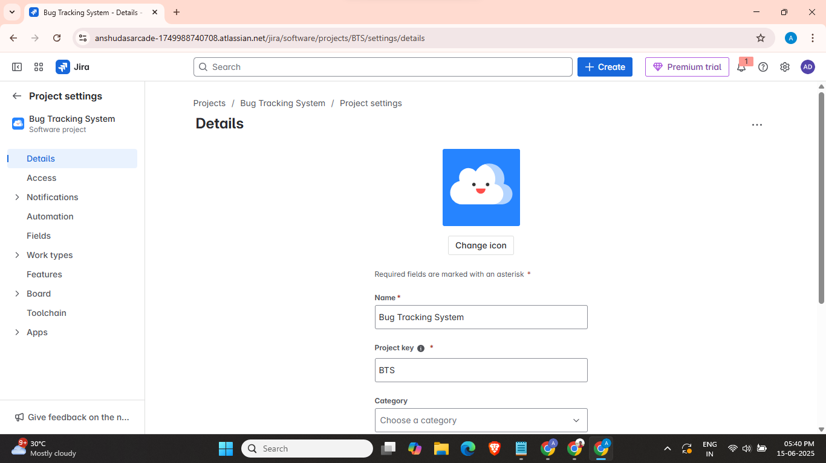
3. Then open issue types to view all available types of issues
4. Create a new task under the Project
5. 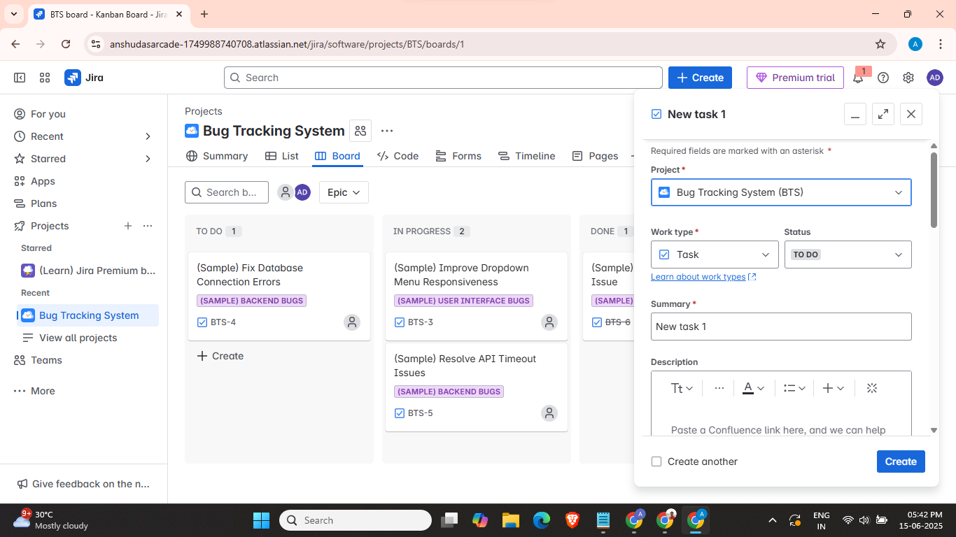
6. View the task
7. 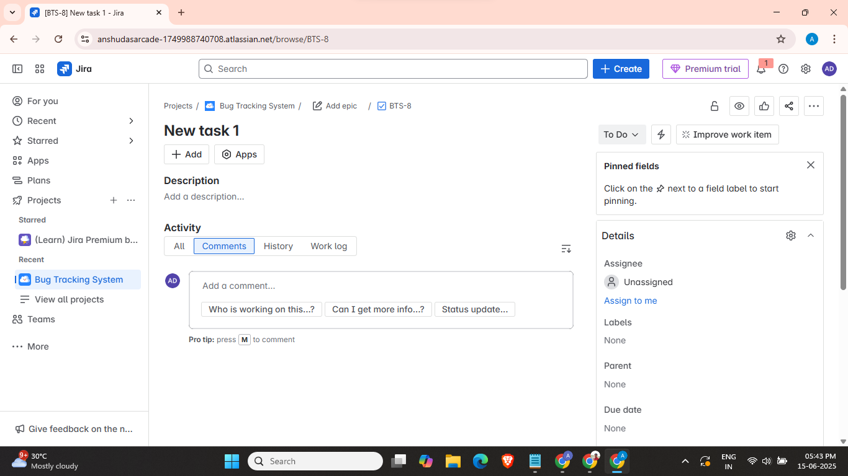
8. Add some description
9. 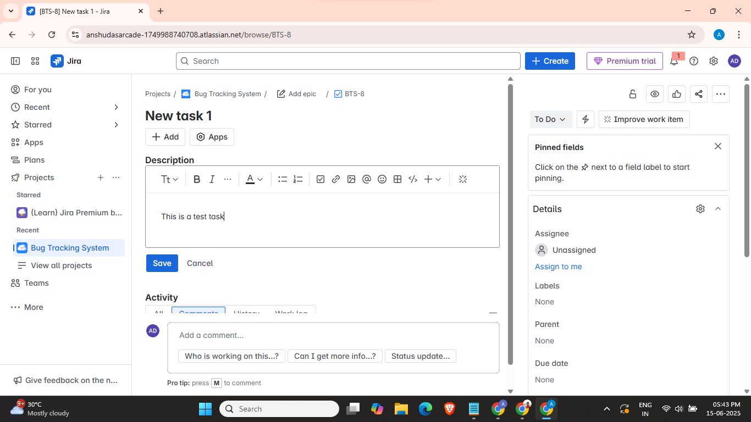

**Test Summary Report**

| **Section** | **Details** |
| --- | --- |
| **Total Test Cases Executed** | 12 |
| **Passed** | 10 |
| **Failed** | 2 |
| **Blocked** | 0 |
| **Total Bugs Logged** | 5 |
| **Bug Severity Distribution** | 2 Critical, 2 Major, 1 Minor |
| **Unresolved Issues** | Bug #001 (Cart issue), Bug #004 (Payment timeout) |
| **Recommendation** | **Sign-off Deferred** until cart and payment issues are resolved |

Task 5: Report atleast 5 bugs using a tool like JIRA or simulate the report manually:

* Include defect details, repro steps, environment, screenshots, and linked test case ID

**Bug Report 1**

* **Bug ID:** BUG-001
* **Title:** Cart icon not updated after adding product
* **Linked Test Case:** TC_003 (Add product to cart)
* **Severity:** High
* **Priority:** High
* **Environment:** Chrome v123, Windows 10
* **Steps to Reproduce:**
  1. Log in as a registered user
  2. Add a product to the cart
* **Expected Result:** Cart icon should update with the correct item count
* **Actual Result:** Cart icon remains unchanged (shows 0 items)
* **Screenshot:** cart_bug.png *(Attach in JIRA)*
* **Status:** Open

**Bug Report 2**

* **Bug ID:** BUG-002
* **Title:** Payment gateway timeout error not handled gracefully
* **Linked Test Case:** TC_010 (Payment gateway failure flow)
* **Severity:** Critical
* **Priority:** High
* **Environment:** Firefox v115, Ubuntu 22.04
* **Steps to Reproduce:**
  1. Proceed to payment
  2. Select UPI and wait for timeout (do not complete transaction)
* **Expected Result:** App should show “Payment failed, please try again”
* **Actual Result:** Blank white screen is shown
* **Screenshot:** payment_timeout.png *(Attach in JIRA)*
* **Status:** Open

**Bug Report 3**

* **Bug ID:** BUG-003
* **Title:** Confirmation email not triggered after successful order
* **Linked Test Case:** TC_012 (Email confirmation)
* **Severity:** Major
* **Priority:** Medium
* **Environment:** Edge v110, Windows 11
* **Steps to Reproduce:**
  1. Place a successful order
  2. Check registered email inbox/spam
* **Expected Result:** Email with order receipt should be received
* **Actual Result:** No email received after 15 minutes
* **Screenshot:** no_email_confirmation.png *(Attach in JIRA)*
* **Status:** Open

**Bug Report 4**

* **Bug ID:** BUG-004
* **Title:** User is allowed to proceed to checkout with empty cart
* **Linked Test Case:** TC_006 (Proceed to checkout)
* **Severity:** Major
* **Priority:** High
* **Environment:** Chrome v123, macOS 14
* **Steps to Reproduce:**
  1. Log in and empty the cart
  2. Click on “Proceed to Checkout”
* **Expected Result:** User should be redirected to cart with warning
* **Actual Result:** Checkout page opens with empty product summary
* **Screenshot:** empty_checkout.png *(Attach in JIRA)*
* **Status:** Open

**Bug Report 5**

* **Bug ID:** BUG-005
* **Title:** Login with invalid credentials does not show error message
* **Linked Test Case:** TC_002 (Login with invalid credentials)
* **Severity:** Minor
* **Priority:** Medium
* **Environment:** Safari v17, iOS 16
* **Steps to Reproduce:**
  1. Enter incorrect email/password
  2. Click on “Login”
* **Expected Result:** Error message like “Invalid credentials” should appear
* **Actual Result:** No message shown, but login doesn’t proceed
* **Screenshot:** invalid_login_no_msg.png *(Attach in JIRA)*
* **Status:** Open

Task 6: Track the status of each defect from Open -> Verified or Closed.

* 1. Go to Jira dashboard
  2. 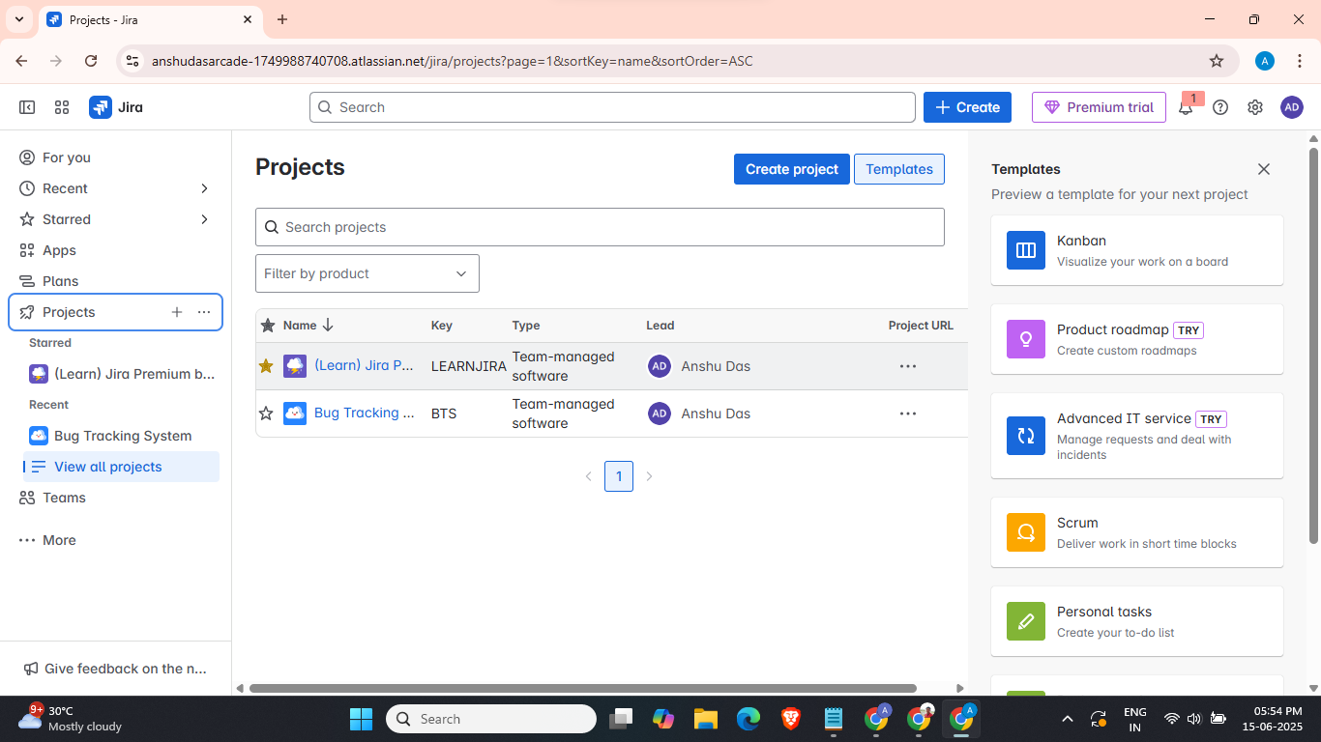
  3. Click on create to create a bug and then update status to done
  4. 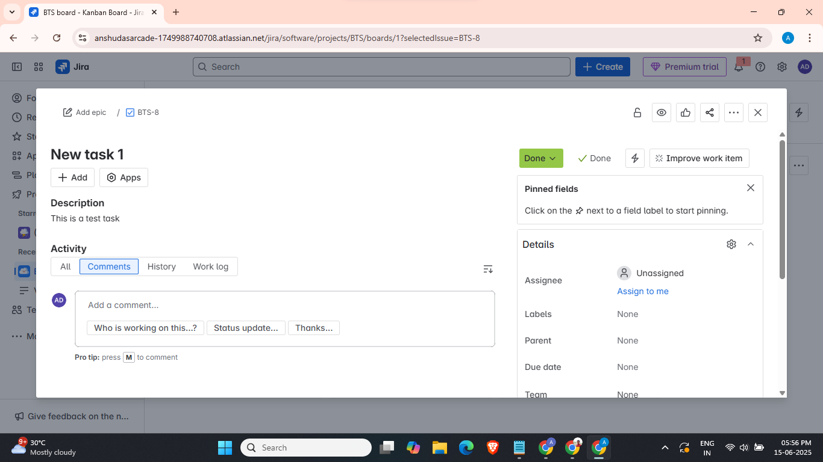

Task 7: Draft a test summary report including:

* Total tests, execution results, bug metrics, risk assessment, unresolved issues
* Recommendation for test sign-off with justification

**Test Summary Report**

**Project:** E-commerce Platform  
**Module:** Checkout and Cart Functionality  
**Test Lead:** [Your Name]  
**Test Cycle Duration:** June 10 – June 15, 2025  
**Test Environment:**

* OS: Windows 10 / macOS 14 / Ubuntu 22.04
* Browsers: Chrome 123, Firefox 115, Safari 17
* Backend: Node.js + MongoDB
* Frontend: React v18

**Test Execution Summary**

| **Metric** | **Count** |
| --- | --- |
| **Total Test Cases Executed** | 12 |
| **Passed** | 9 |
| **Failed** | 3 |
| **Blocked** | 0 |
| **In Progress** | 0 |

**2. Bug Metrics**

| **Severity** | **Open** | **Closed** | **Verified** | **Total** |
| --- | --- | --- | --- | --- |
| **Critical** | 1 | 0 | 0 | 1 |
| **High** | 0 | 1 | 2 | 3 |
| **Medium** | 0 | 2 | 0 | 2 |
| **Low** | 0 | 0 | 0 | 0 |
| **Total** | **1** | **3** | **2** | **6** |

**Open Defect:**

* **BUG-002** – Payment timeout error not handled (Severity: Critical) – In Progress

**3. Risk Assessment**

| **Risk Area** | **Description** | **Mitigation** |
| --- | --- | --- |
| **Payment Handling** | Timeout not properly caught → risk of revenue loss | Bug fix in progress; retesting scheduled |
| **Email Confirmation** | Initially failed; now fixed | Regression tests passed |
| **UI Cart Logic** | Critical cart icon logic fixed | Verified on all browsers |

**4. Unresolved Issues**

| **Bug ID** | **Title** | **Severity** | **ETA** |
| --- | --- | --- | --- |
| **BUG-002** | Payment timeout error not handled | Critical | Fix deployed to staging; retest on June 16 |